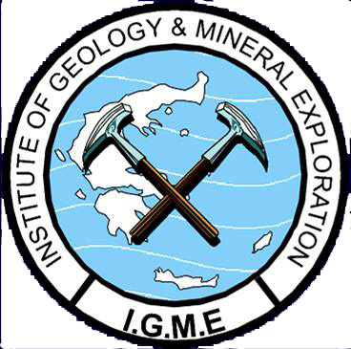
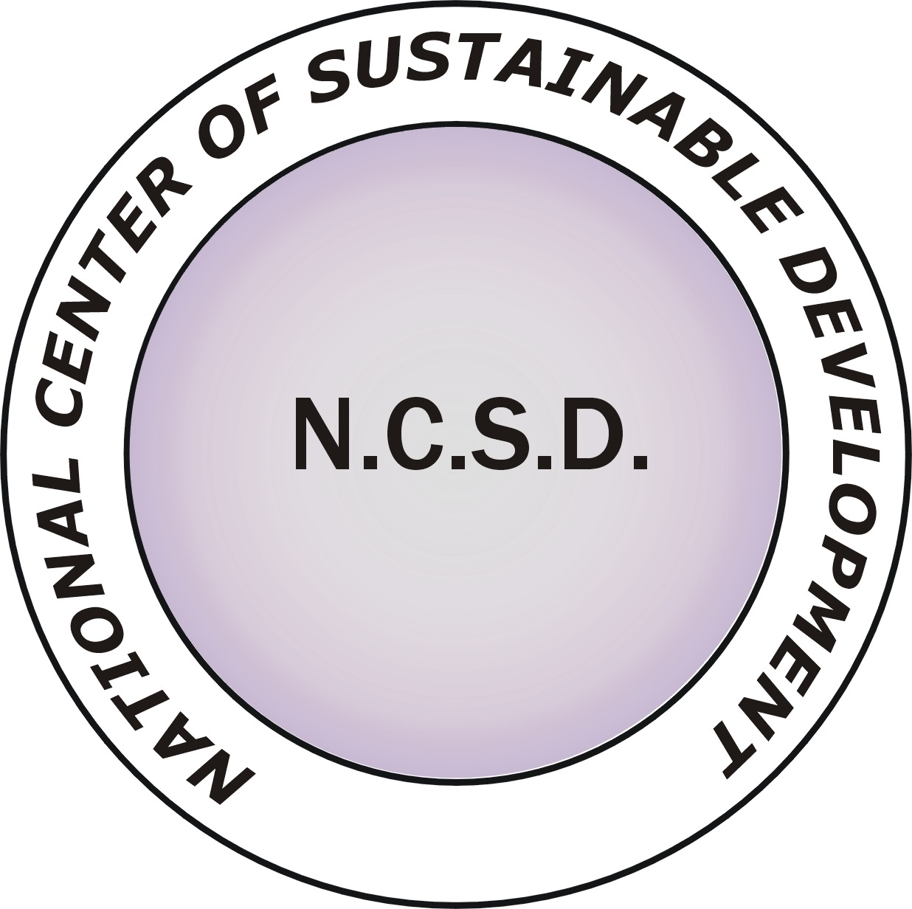


K n o w l e d g e - s h a r i n g W o r k s h o p

CO₂ Geological Storage:
Scientific knowledge - Present situation - Perspectives

Wednesday, 26 June 2013
Central Amphitheatre,
National Center for Sustainable Development (NCSD)
Entrance C, Olympic Village, Acharnae, Greece

R E G I S T R A T I O N F O R M

FIRST & LAST NAME
PROFESSION - POSITION
COMPANY - ORGANISATION - INSTITUTION etc
ADDRESS
(Street, Number,
Postal Code, Area, City)
TELEPHONE NUMBER
E-mail
NOTES

